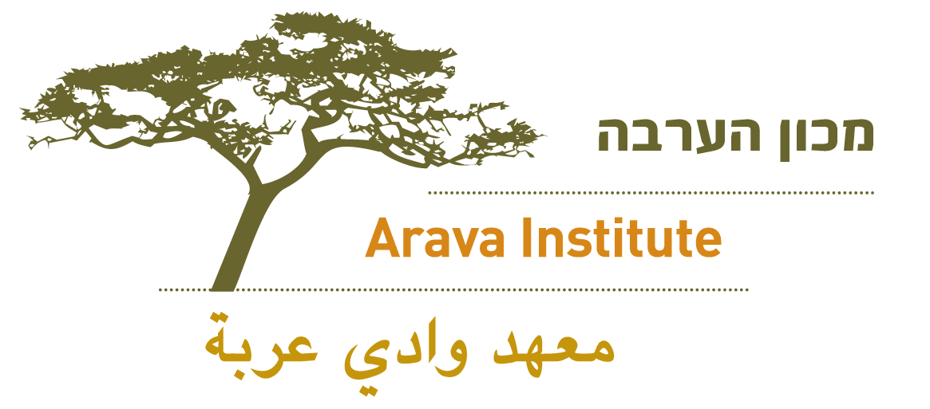

Dear NAME,
Thank you for taking the time to speak with me about the Arava Institute.

I am connecting you with Sarah Rubin, Program Manager, copied here. I know Sarah looks forward to speaking further with you about sharing information about the Arava Institute with your students!
Many thanks,
Your Name

