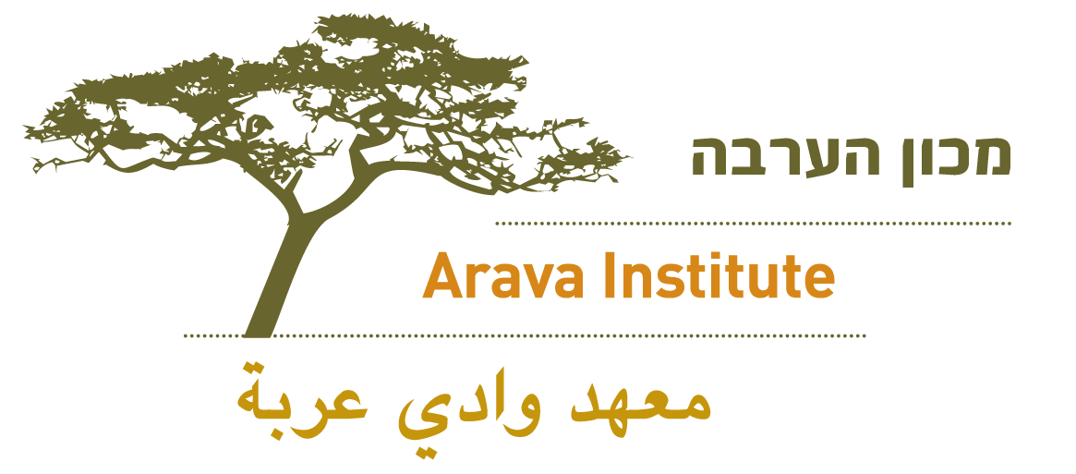

Subject line: Spread the Word!

Dear NAME,
(Personal intro.)
Some of you may know that I attended an exceptional program in Israel called the Arava Institute for Environmental Studies. I studied/interned at the Arava Institute during (SEMESTER, YEAR) and it had a profound effect on me.
The Arava Institute is an environmental institution in southern Israel that brings together students from Israel, Palestine, Jordan, and America. Here, students participate in the most open, honest, and groundbreaking dialogue happening between Jews and Arabs in the Middle East.

I would love more college students to know about this extraordinary place. Please spread the word through email, Facebook, and word of mouth: The Arava Institute is currently accepting applications for fall 2014 and spring 2015!

Do you know a young person who would thrive at the Arava Institute? Please email me and Sarah Rubin, (copied here) Program Manager of Student Recruitment, for more information.
Thanks in advance for spreading the word!
Your Name

