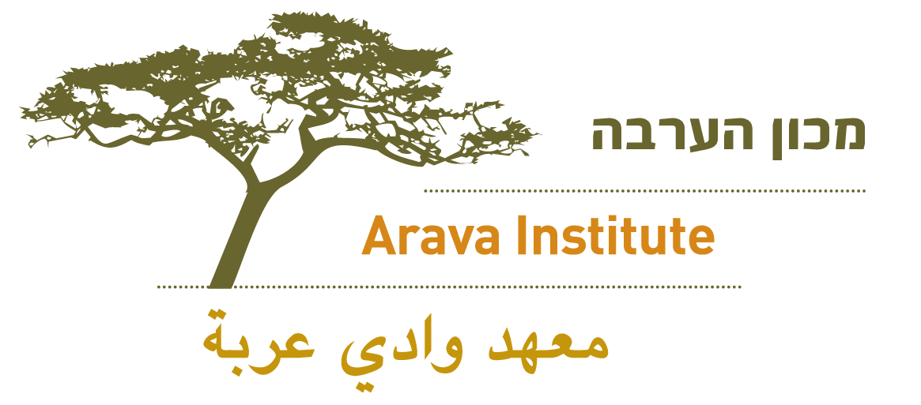

Facebook:
The Arava Institute is accepting applications for fall semester 2014 and spring 2015. I studied abroad at the Arava Institute in (SEMESTER, YEAR) and it was wonderful/amazing/life-changing! My favorite thing about the Arava Institute was _______ and I miss it every day!
www.arava.org

(Remember to share a photograph from your time at the Arava Institute!)

Twitter:
The #Arava Institute, an amazing #environmental program in #Israel, is accepting applications for fall 2014! Apply now! www.arava.org

