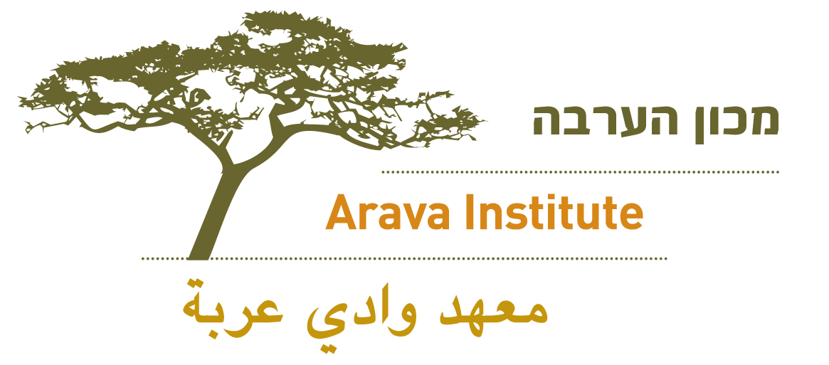

Hello NAME!
(Personal intro if applicable.)
Is this a good time to talk? I'm an alumnus/alumna of (UNIVERSITY) and I’m calling to let you know about an exceptional program in Israel called the Arava Institute for Environmental Studies. I studied/interned at the Arava Institute during (SEMESTER, YEAR) and it had a profound effect on me.
Are you familiar with the Arava Institute? If not, I’d love to tell you about it:
The Arava Institute is an environmental institution in southern Israel that brings together students from Israel, Palestine, Jordan, and America, and provides them with the skills to become the next generation of environmental leaders who are poised to work cooperatively across borders.

(Share one of your favorite memories if you’d like.)
The Arava Institute is currently accepting applications and it would be great for students at (UNIVERSITY) to have the opportunity to study abroad or intern at the Institute. Would you be willing to speak with Sarah Rubin, the Program Manager of Student Recruitment, about how to reach students at (UNIVERSITY) about studying at the Arava Institute? If not, do you have the name of someone else she could speak to?
Thank you for taking the time to speak with me! Sarah will be in touch with you/your contacts soon.

